

Community - Social Tool Kit

Googlers - Social Tool Kit
What is Solution Challenge?
Who can participate?
Ways you can support
Timeline for Solution Challenge
Social Toolkit
Invite Email

Hey,

Registrations for the Solution Challenge 2026 India - Build with AI is officially LIVE!

We are reaching out to invite you to support the Solution Challenge 2026 India - Build with AI, organized by GDG on Campus India in collaboration with Hack2skill. This isn’t just about writing code; it’s about writing the future.
This year, we are breaking the mold. We are thrilled to announce that the Solution Challenge 2026 will run in tandem with the "Build with AI" campaign!
This means you won’t just be solving problems, you'll be solving them with the most advanced intelligence on the planet.

What is Solution Challenge?
The Solution Challenge is a premier global stage for student developers to tackle the world’s most pressing issues using the power of Google technology.

By stepping into this challenge, student developers aren't just building an app; they are building a future. They will:
- Master In-Demand Skills: Get hands-on with Gemini, Antigravity, Flutter, and Google Cloud.
- Create Social Impact: Align their project to solve real-world problems.
- Launch their Career: Gain invaluable experience, boost their portfolio, and earn global recognition from Google experts.

Who can participate?
This challenge targets student developers from India, who are currently enrolled in college/university and their age must be 18 years or above.

Ways you can support
- Raise awareness about the Solution Challenge (Using Social Kit provided below) within your networks and inspire student developers to participate.
- Motivate student developers to address real-world issues through innovative solutions using Google technologies.
- Showcase the benefits of participation, including mentorship opportunities, skill development, and the 10 lakhs INR prize pool.

Timeline for Solution Challenge
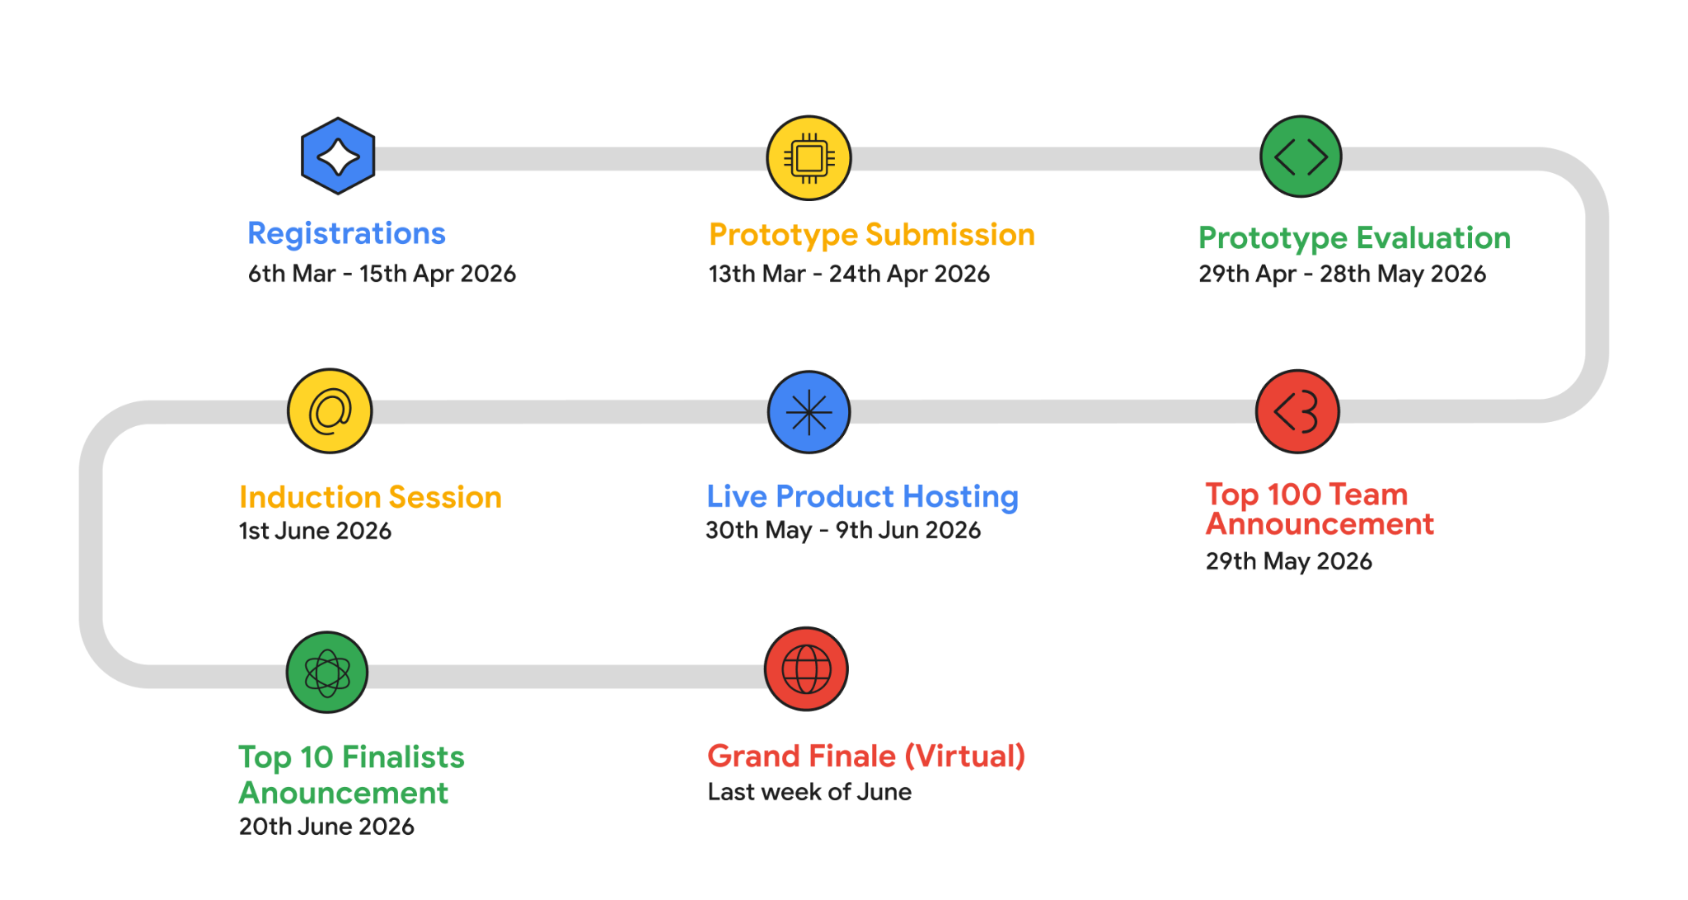
Note: Timelines are subject to change

Click here to Register Now

Spread the word and make use of the social kit provided below to build excitement in the communities until then!

Social Toolkit
We’ve curated sample content and design assets for you to use in promoting the Solution Challenge within your network.

Platform Assets and Promotional Content
Platform | Content | Creative
  LinkedIn | Ready to turn your ideas into impact?  Join the Solution Challenge 2026 India - Build with AI.  This is your opportunity to turn bold ideas into real-world impact using advanced AI tools and Google technologies. Step beyond the classroom, collaborate with ambitious peers, and build solutions that truly matter to your community.  Your 2026 Innovation Journey  ✨ Collaborate - Connect with a dynamic network of student developers across India.  💡 Create - Design solutions aligned with global impact goals and real community needs.  🚀 Grow - Access mentorship and expert-led training sessions.  🏆 Achieve - Compete for ₹10 lakhs INR prize pool, national recognition, and exclusive Google swag.  #BuildWithAI #solutionchallenge #GDGonCampus  Ready to make an impact and win big? 🏆  Register now: Click here to register  Note: Make sure you tag Hack2skill | Creative Link  Gif Link
  Twitter/X | 🚀Join the SolutionChallenge 2026 India - Build with AI!  ⏩ Solve Real-World Challenges Using Technology  ⏩ Collaborate with Driven Student Developers  ⏩ Learn Directly from Industry & Google Experts  ⏩ Compete for ₹10 lakhs INR Prize Pool  #BuildwithAI  Register Now: Click here to register  Note: Make sure you tag Google for Developers India & Hack2skill | Creative Link  Gif Link
  Instagram | 🚀 Time to stop learning and start leading!  Registrations for the GDG On Campus India Solution Challenge 2026 – Build with AI are officially LIVE!  Build with cutting-edge AI. Solve real-world challenges. Show what student developers are truly capable of.  🛠️ Your 2026 Innovation Journey:  ✅ Collaborate – Join a thriving network of student developers across India  ✅ Create – Tackle problems aligned with the overall theme  ✅ Grow – Access mentorship and exclusive training from Google experts  ✅ Achieve – Win from a prize-pool of ₹10 lakhs  💡 Registrations are open. Start building what matters.  Register now: Click here to register  Note: Make sure you tag Hack2skill | Creative Link  Gif Link

Invite Email
Subject: Stop scrolling, start coding GDG on Campus India Solution Challenge 2026 - Build with AI is here!
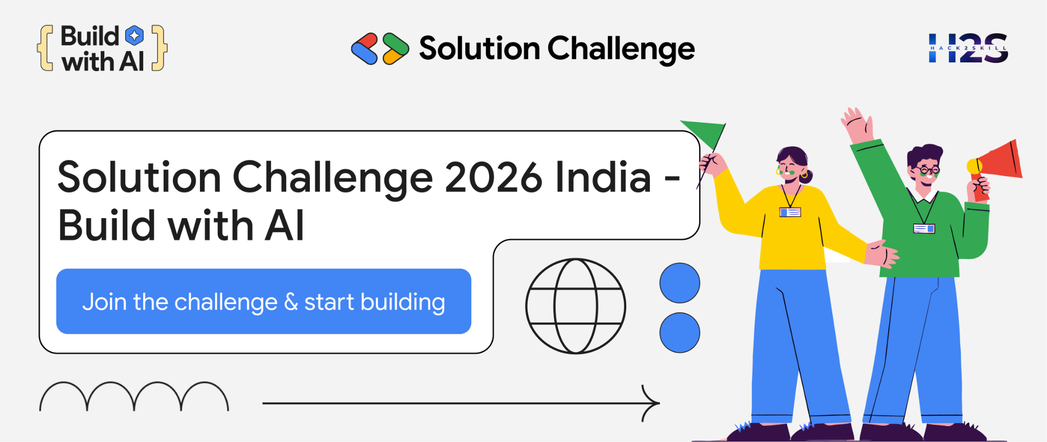
Hello <<Name>>,
Let’s be honest: our communities have bugs. We aren't talking about a missing semicolon or a broken API - we’re talking about real-world glitches in healthcare, education, and sustainability that a simple "restart" won’t fix.
GDG On Campus India, in collaboration with Hack2skill, is officially inviting you to the Solution Challenge 2026: Build with AI. This isn't just another hackathon to add a line to your resume. This is your chance to stop building apps that just "check boxes" and start engineering solutions that actually move the needle.
Your Mission:
Use Google technologies to tackle a local problem. Whether it’s an AI that talks to plants or a platform that solves traffic woes, if it leverages Google tools and benefits humans, we want it.

The Roadmap to Glory:

Note: Timeline are subject to change**
Why Participate?
 | Work on real-challenges that create an impact in the real-world. |  | Use Google Technologies to turn your ideas into reality.
 | Form a team, refine your solution and pitch it in front of the jury. | 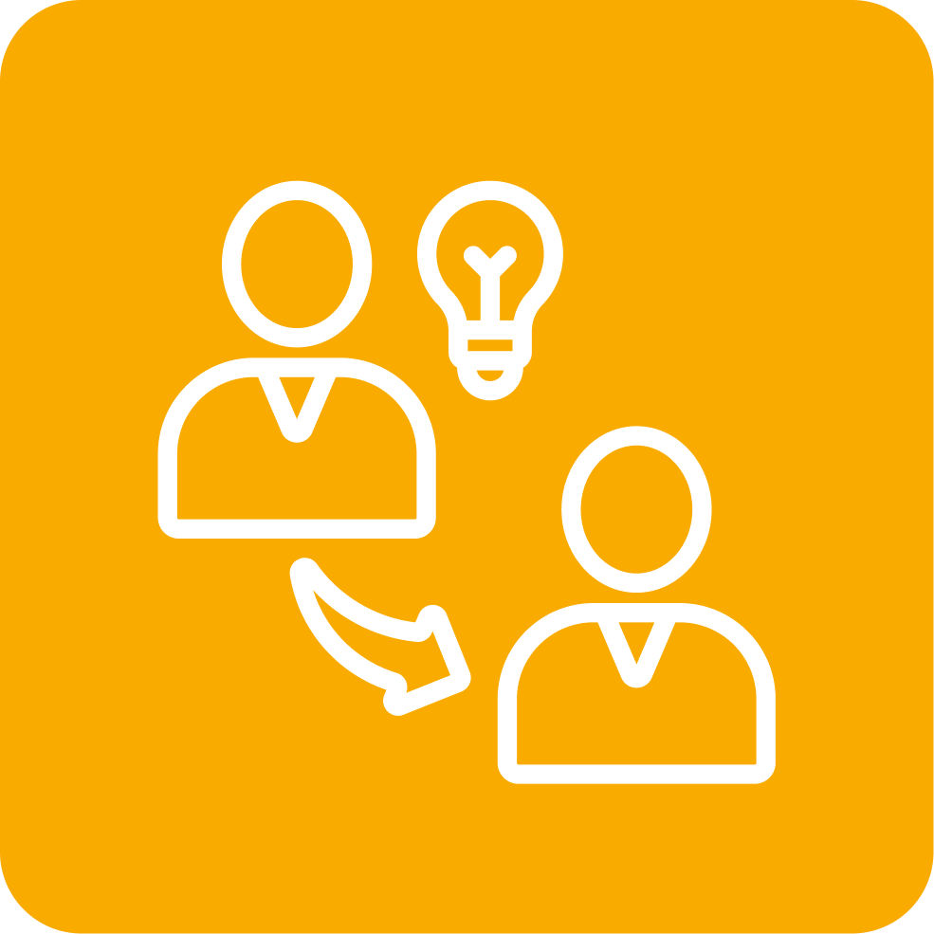 | Get guidance from the industry experts and earn the chance of showcasing your project on the national stage.

Join the Google Solution Challenge 2026 India - Build with AI

Have questions?
Mail us at solutionchallengesupport@hack2skill.com

Regards,

